

[Document title]

[Document subtitle]



[Date]

[Company name]

[Company address]

Contents

List of Figure 2

Question 01 3

a) 3

Code 3

Output 3

b) 3

Code 3

Output 4

C) 4

Code 4

Output 5

Question 02 5

Code 5

Output 6

Test Case 01 6

Test Case 02 6

Test Case 3 6

# List of Figure

Figure 1: Circle 3

Figure 2: Five circle 4

Figure 3: Olympic Ring 5

Figure 4: Test Case 1 6

Figure 5: Test Case 02 6

Figure 6: Test Case 03 6

# Question 01

## a)

### Code

function [x, y] = createCircle(center, r)

t = linspace(0, 2*pi, 200);

x = center(1) + r*cos(t);

y = center(2) + r*sin(t);

plot(x,y, 'Linewidth', 3)

xlabel('--->x')

ylabel('--->y')

title('Circle')

hold on

end

### Output

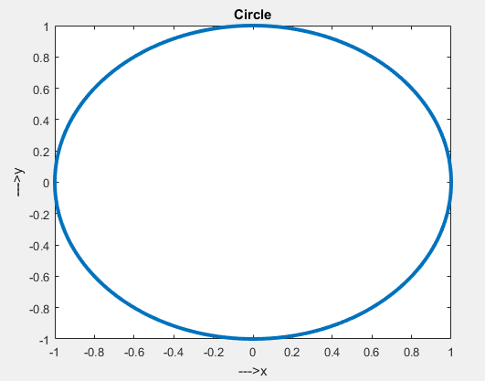

Figure : Circle

## b)

### Code

close all

clc

clear all

[x, y] = createCircle([0, 0], 1);

[x1, y1] = createCircle([0, 0], 2);

[x2, y2] = createCircle([0, 0], 3);

[x3, y3] = createCircle([0, 0], 4);

[x4, y4] = createCircle([0, 0], 5);

xlabel('x'), ylabel('y'), title('Circles')

axis equal

### Output

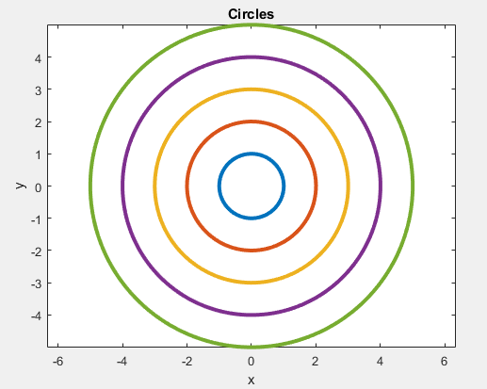

Figure : Five circle

## C)

### Code

clc

clear all

close all

[x, y] = createCircle([0, 0], 1);

[x1, y1] = createCircle([2.2, 0], 1);

[x2, y2] = createCircle([4.4, 0], 1);

[x3, y3] = createCircle([1, -1], 1);

[x4, y4] = createCircle([3.2, -1], 1);

xlabel('x'), ylabel('y'), title('Olympic Ring')

axis equal

### Output

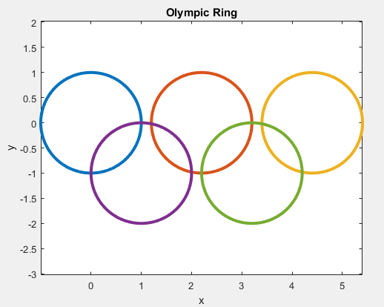

Figure : Olympic Ring

# Question 02

## Code

function [finalValue] = stockExhance(initialValue,price,buy,sell)

initialValue_=initialValue;

finalValue=0;

if initialValue < min(price)

finalValue=initialValue;

else

while(initialValue>=0)

for i=1:length(buy)

if initialValue> buy(i)*price(i)

initialValue=initialValue-9.95-buy(i)*price(i);

else

finalValue=finalValue+sell(i)*price(i);

initialValue=initialValue-9.95;

end

end

end

end

disp(['With an initial investment of ',num2str(initialValue_),' TL,',' the final value is ',num2str(finalValue)])

end

## Output

### Test Case 01

clc

clear all

close all

load SrvStockPrices

initialValue=100;

finalValue=stockExhance(initialValue,price,buy,sell);



Figure : Test Case 1

### Test Case 02

clc

clear all

close all

load SrvStockPrices

initialValue=1000;

finalValue=stockExhance(initialValue,price,buy,sell);



Figure : Test Case 02

### Test Case 3

clc

clear all

close all

load SrvStockPrices

initialValue=10000;

finalValue=stockExhance(initialValue,price,buy,sell);



Figure : Test Case 03